A TECHNICAL REPORT
ON
6 MONTHS STUDENTS INDUSTRIAL WORK EXPERIENCE SCHEME (SIWES)
SUBMITTED TO
THE UNIVERSITY OF LAGOS
IN
PARTIAL FULFILLMENT OF THE REQUIREMENT FOR THE AWARD OF THE DEGREE OF BACHELOR OF SCIENCE
IN THE
DEPARTMENT OF PETROLEUM AND GAS ENGINEERING
(FACULTY OF ENGINEERING)
AS WAS UNDERTAKEN BY
PRECIOUS, ADELAE SUNDAY (210409060)
AT
PHYSICS INSPIRED DRILLING SIMULATION COMPANY (PHIDRILLSIM)
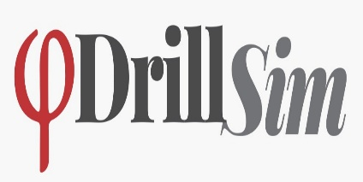
OCTOBER 2026

